Little SPARK: Simple Play Adaptations to Reference for Kids

Big Step-by-Step
Description: | Image:
The Big Step-by-Step is a sequential voice output communication device. Pressing the large button on the top of the device activates a message. With each subsequent press of the button a new message is activated. Powered by a 9-volt battery.  Purchasing Information  Quick Start Guide | 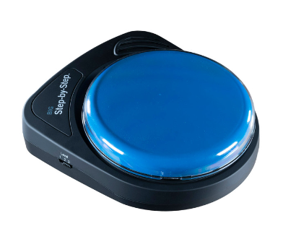

Who Might Benefit?
Those who need support for verbal communication and structured exchanges, have difficulty following step-by-step directions, require tools for independent literacy activities, and possess the fine motor ability to press a button to activate the device.
Why Use?
Provides an opportunity to engage in simple conversation exchanges, hear step-by-step directions repeated, independently listen to books or similar activities.
Instructions for Use: | Adaptation Ideas:
Environmental Considerations  - Use in any environment and take it on the go.  Positioning  - Use in any position and on most surfaces.  Basic Play/Use  - Record the message and press the switch top to activate the message.  Extended Play/Use  - Provide step-by-step instructions, make requests, share information, use as labels for classroom centers/areas, play the sequential steps for washing hands/self-care routines.  Play/Use with Others  - Make games interactives, participate in back and forth communication exchanges. | Stabilize It  - Use Dycem or shelf liner under the item or attach Velcro.  Simplify It  - A single repeating message can be recorded on the device rather than each message being different.  Add Sensory Cues  - Add sensory cues to the activation button such as puffy stickers, puffy paints, different textures, or change the button color.  Communication Support  - Vocabulary words would depend on the activity.  Alternative Uses  - Link multiple together with velcro to foam board to provide choices, visual/auditory sequence/steps, provide first/then support, or construct simple sentences/phrases.  - Connect the device to switch-activated toys using the switch input jack.
Words to Encourage Play/Use
Push  | Listen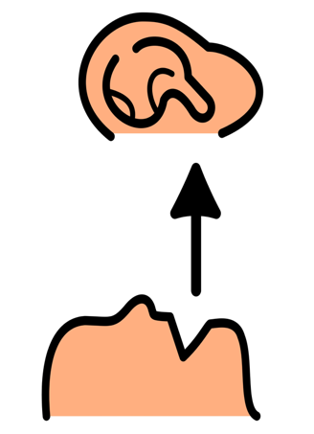 | All Done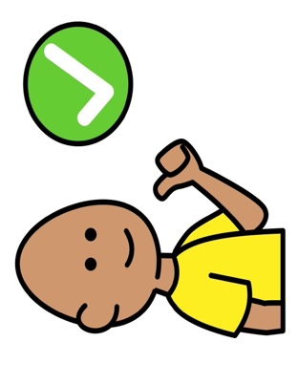
My Turn | Your Turn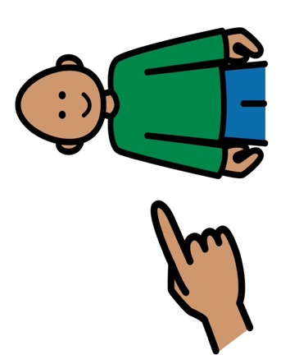 | More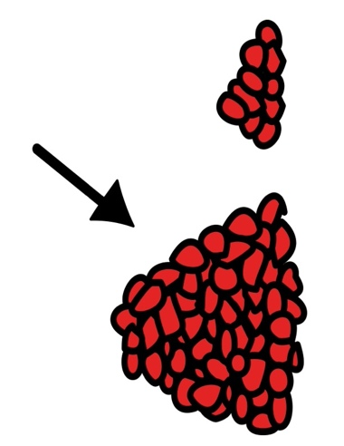
Wait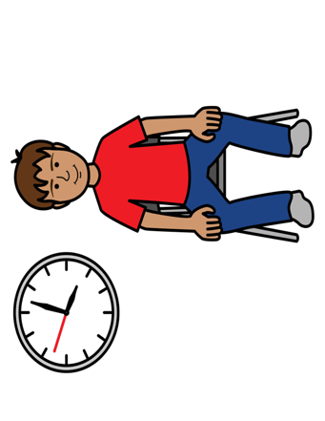 | Stop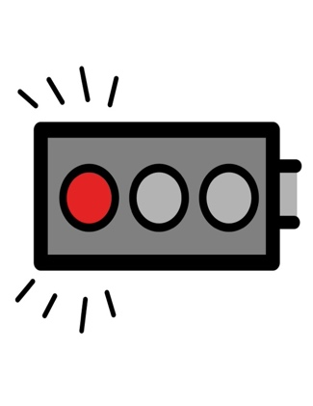 | Go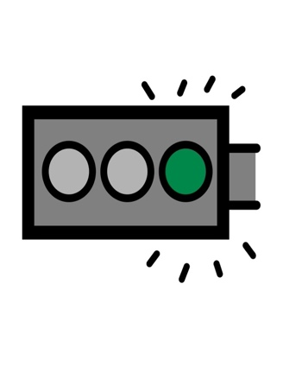
*”Adaptations” adapted from: Haugen’s Modes for Adapting Toys based on materials from the "Let's Play" Project at the University of Buffalo
PCS is a trademark of Tobii Dynavox, LLC. All rights reserved. Used with permission.

